**CREATING AN INSTANCE IN AWS:**

* Naming the virtual machine and selecting OS:

* Create a key pair and download as a .pem file

* Set the configuration to default:

* Instance is created.

dHOW TO CONNECT TO VM FROM YOUR LOCAL:

* In MobaXterm, Set IPv4 (in AWS Instance) at remote Host and Specify username to Ubuntu and in Advanced SSH settings, Check private key to the .pem path and hit OK

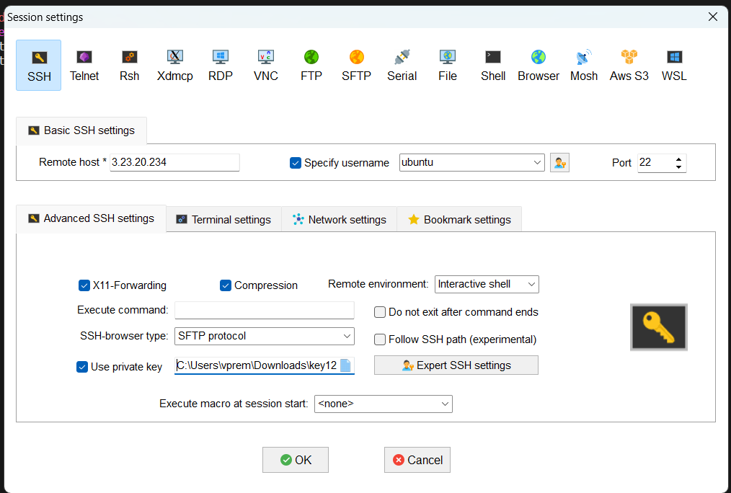

* Once you done all of these, we can see the ubuntu terminal in your local:

